Software Requirements Specification

for

Vehicle Management System

Prepared by

|  |  |
| --- | --- |
| **Student Name** | **Student ID** |
| Haque, Tasriful | 18-38661-3 |
| Ajoy Roy | 20-42174-1 |
| Wasek Al Azad, Md | 19-39381-1 |
| Sakib, Shadman | 19-39373-1 |
| Farjana, Methila | 19-39692-1 |
| Onik,Md Fahtin Emtiaz | 19-40471-1 |

7 December 2022

Table of Contents

Table of Contents ii

Revision History ii

1. Introduction 1

1.1 Purpose 1

1.2 Document Conventions 1

1.3 Intended Audience and Reading Suggestions 1

1.4 Product Scope 1

1.5 References 1

2. Overall Description 2

2.1 Product Perspective 2

2.2 Product Functions 2

2.3 User Classes and Characteristics 2

2.4 Operating Environment 2

2.5 Design and Implementation Constraints 2

2.6 User Documentation 2

2.7 Assumptions and Dependencies 3

3. External Interface Requirements 3

3.1 User Interfaces 3

3.2 Hardware Interfaces 3

3.3 Software Interfaces 3

3.4 Communications Interfaces 3

4. System Features 4

4.1 System Feature 1 4

4.2 System Feature 2 (and so on) 4

5. Other Nonfunctional Requirements 4

5.1 Performance Requirements 4

5.2 Safety Requirements 5

5.3 Security Requirements 5

5.4 Software Quality Attributes 5

5.5 Business Rules 5

6. Other Requirements 5

Appendix A: Glossary 5

Appendix B: Analysis Models 5

Appendix C: To Be Determined List 6

Revision History

|  |  |  |  |
| --- | --- | --- | --- |
| **Name** | **Date** | **Reason For Changes** | **Version** |
|  |  |  |  |
|  |  |  |  |

# Introduction

## Purpose

Vehicle management system is an online platform that provides vehicle repair and emergency services. Users can book a home service or on-road service. They can also checkup their car monthly. If the vehicle gets damaged, then the vehicle can be repaired as well. Vehicle renting will also be available. Users can pay their payment by using online payment option or cash and using e-banking. The record of the users and the system includes its number, name, source, destination on which it is available, whereas record of booking status includes date, time and location.

## Document Conventions

This document uses the following conventions: Database Distributed Database Entity Relationship

## Intended Audience and Reading Suggestions

This project is a prototype for the vehicle management system. The system being developed is a system to handle the business needs of vehicle servicing, vehicle checkup, vehicle fixing and renting out vehicles to customers, maintaining records and data on operating the customer portal website, and reporting the state of the system to the company. The system does not fulfill any other needs of the business.

## Product Scope

The scope of the system is represented in four different aspects of the system: Customer Service Module, Web Portal Module, Management Module and Reports and Analytics Module

The scope of the Customer Service Module is to provide a clear and easy to use layout for employees and customers to follow. Customers make appointment of servicing or renting a car and employees doing their work accordingly.

The scope of the Customer Web Portal is to vehicle servicing, vehicle checkup, vehicle fixing and rent vehicles to customers online. The module will interface with the management module but will not perform any of that module’s duties.

The scope of the Management module is keeping track of the workers, customers and vehicle. This module’s purpose will be to contain the data on the workers, customers, vehicle and information and about them. Take appointment of the customers and keep the track of reserving service time that the customers made. The management module will also keep track of the vehicle maintenance.

The scope of the reports and analytics module is to provide a predetermined spot that will contain all of the reports made from employees on vehicle service, checkup, fixing and rentals. It will help the store managers and corporate office when they need to file reports and check on rentals. Also keep track of the system if it is working smoothly or any changes is needed to the system.

## References

SYSTEM: A CASE STUDY, By Syed Abdullah Al Nahin ,In 2019. Web Page. URL: http://lib.buet.ac.bd:8080/xmlui/bitstream/handle/123456789/5466/Full%20Thesis.pdf?sequence=1&isAllowed=y

lib.buet.ac.bd

# Overall Description

## Product Perspective

## *The system has been designed with four modules in mind. These modules are the customer service module, the web portal module, the garage owner module, and the reports and analytics module. These four modules will make up the structure of the system. The customer service module will be the part of the system that is supposed to provide the employee with everything they need to perform their duties. The web portal module will be the part of the system that handles the website where the customers will be able to go through an automated process where they can choose any option like - Home & On-road Emergency repair Support, Vehicle Health Consultancy, Vehicle Parts e-commerce platform and they can check the nearest garage from their location. The garage owner module help the garage owner or manager to communicate with the customers can quickly locate where the customer is. The reports and analytics module will be the part of the system that will be used to generate reports from the remaining three modules for the purpose organizing the data on the status of the company. The system will be able to interact with outside systems to process payment on behalf of the company.*

## Product Functions

## *• The System will contain a Customer Service module that will allow Store and Corporate*

## *employees to provide information to customers*

## *• The System will contain a Customer Service module that will allow Store and Corporate*

## *employees to collect payments*

## *• The System will contain a Customer Portal Website that will provide information to the public and customers about the company and operations of the company.*

## *• This information will include Locations, Hours of operation, contact information, availability, vehicle service system, vehicle repair, rental vehicles, price estimate, and any other necessary information that are needed by the company.*

## *• The customer portal website will provide the customer with the closest location to their place and then up to the next five closest locations in addition to hours of operations, contact info and directions.*

## *• The System will generate an inventory capacity report for the desired time and location.*

## *• The management module will allow the system to track vehicle maintenance.*

## *• The System will contain a Report and Analytics Module that will serve the purpose of*

## *generating reports on the operations of the company.*

## *• The System will contain a Report and Analytics Module that will be capable of generating reports for items such as sales, maintenance, vehicle history, operations, rentals, repaied vechicles, service and insurance.*

## *• The System will contain a Report and Analytics Module that will be capable of generating reports for a desired time and location.*

## *• The system will send the daily operations to headquarters at the end of each business day.*

## *• The system will generate a backup of all data weekly for the purpose of data loss prevention at the headquarters.*

## User Classes and Characteristics

The users will be customers which can include any vehicle owner who will need emergency vehicle repair Support. Other users of the system will be the garage owner and the admin . garage owner will all be using windows desktops to conduct their customer on the system but the system will need to accommodate the variety of devices that the customers will have. The customers will have mobile devices running several different operating software including android, iOS, and blackberry. The full website also must accommodate these.

## Operating Environment

Operating environment for the vehicle management system is listed below: Processor: Intel Xeon processor 3500 series HDD: Minimum 500GB Disk Space RAM: Minimum 16GB OS: Windows 8.1, Linux Database: SQL Server 2014 (SQL14) For Client (minimum requirement): Processor: Intel Dual Core HDD: Minimum 80GB Disk Space RAM: Minimum 1GB: Windows 7, Linux Apple Android Google Chrome Microsoft Internet Explorer Mozilla Firefox.

## Design and Implementation Constraints

• The application will use php, Ajax, JavaScript, jQuery and css as main web technologies. • HTTP and FTP protocols are used as communication protocols. FTP is used to upload the web application in live domain and the client can access it via HTTP protocol • Several types of validations make this web application a secured one and SQL Injections can also be prevented. • Since Vehicle Management System is a web-based application, internet connection must be established. • The Vehicle Management system will be used on PCs and will function via internet or intranet in any web browser.

## User Documentation

A range of short document types like guidelines, tutorials, frequently asked questions will be there in HyperText Markup Language and Portable Document Format will be there to describe the use of the software system.

## Assumptions and Dependencies Regularity Policies

Each center user has account created and authenticated by admin. This Website can be accessible within company’s intranet and other user can see the all details about the franchisee. Each user has to first login itself to present him/her after entry in franchisee. This will be done automatically.no user can share their username and password to each other. Limitations: There is no limitation in the operating system in which Vehicle Management system will work. However, the Vehicle Management System and the database will work on a server that needs to be always online. Users can access the system with any internet browser.

# External Interface Requirements

## User Interfaces

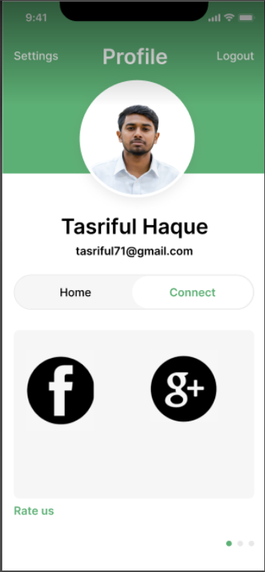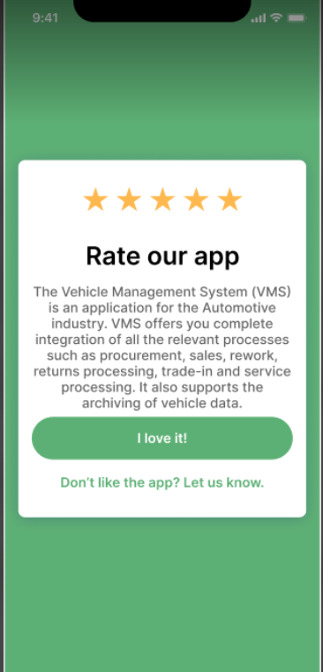

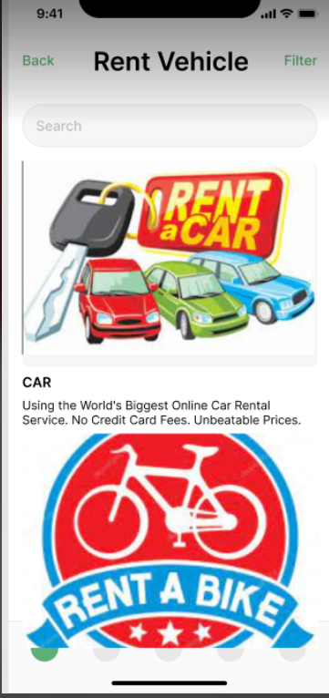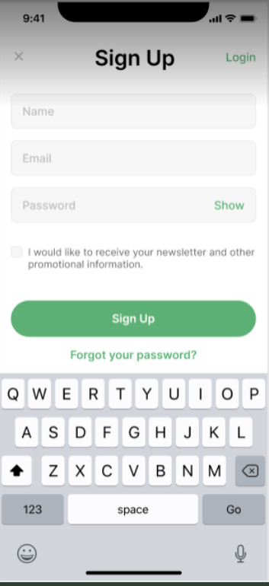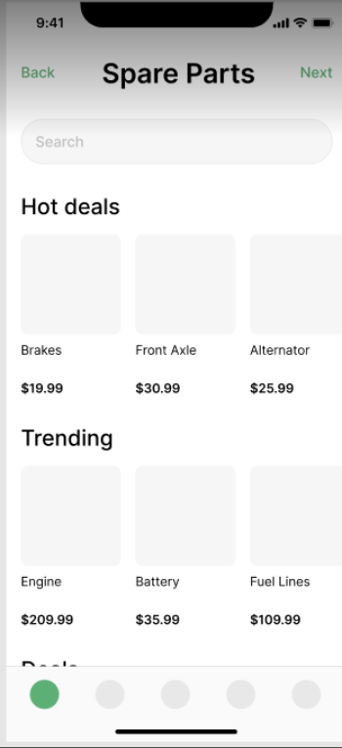

## Hardware Interfaces

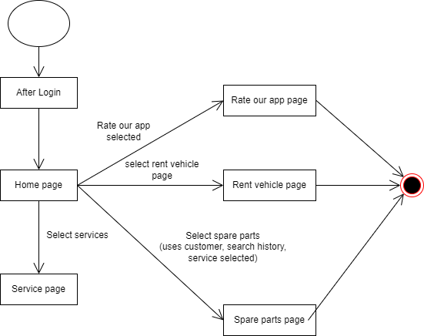

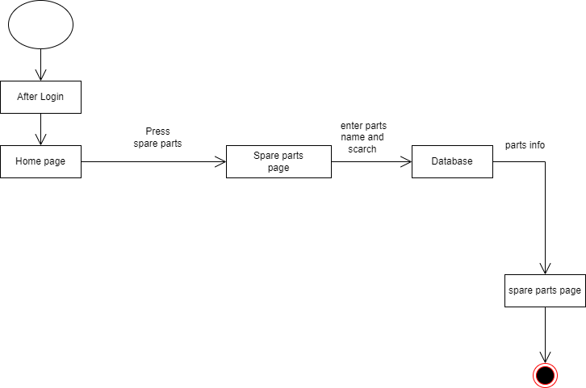

## Software Interfaces

### Android 8 or later

The android system sends the devices location to google location services. Android 8 and later versions are selected because the software might not work well with earlier versions because of hardware, software and google service limitations.

### google play service or Apple store

Google play services/App store must exist in the device so that the software can be downloaded and run properly. Also, Google location service can not work without this which is a big part of the software.

### Google location service/Google maps

Google location service is used to pinpoint the location of the customers who call for repair service.

Without the location and map service customers can not locate nearby garages and mechanics can not locate the damaged vehicle/customers location.

## Communications Interfaces

### Email

Email is required for verification, contact and complain purposes.

### Chrome

Although other browsers can be used to avail the services chrome gives an advantage as it is connected to all google services by default.

### Communication Standard

An FTP based communication needs to be implemented in the system to be able to ensure safety of the clients. So that clients’ details are well secured and can not be accessed by just anyone using the site.

# System Features Vehicle Management System:

# Vehicle management system is integral part of travel. Analyzing the websites of some of the most popular vehicle management system provider companies from across the world, we observe that each has some defining structure that becomes a characteristic of that company.

# 4.1 Information

# This system will contain a module, which is Customer Service module. When any customer buys the product, this module will allow the stake holders to gather necessary information about the customer.

# 4.2 Payment

# This system will contain another module which will allow the employee to collect payments.

# 4.3 Portal Website

# This system will contain a customer portal website which will allow the customer and the common people to know about the company.

# 4.3 Multifunctional

# This information will include Locations, Hours of operation, contact information, availability, vehicle service system, vehicle repair, rental vehicles, price estimate, and any other necessary information that are needed by the company.

# 4.4 Inventory capacity report

# The System will generate an inventory capacity report as and when required.

# 4.5 Fuel management

# Efficient fuel consumption is a key concern for fleet managers as fuel costs represent a large part of the budget of a company. With this module, you can monitor fuel levels 24/7 and see how often vehicles are being refueled and drained. This helps you and your team to identify cases of leaks or theft quickly. You can set alarms to warn you and the driver immediately, whenever draining takes place and get a permanent measurement of the fuel level in tanks. Average fuel consumption is also calculated, per vehicle and time period.

# 4.6 Route planning and monitoring

# This feature will help to monitor the execution of routes and anticipate future events, supporting fleet management decisions, minimizing fuel consumption and increasing productivity. Customers will enjoy faster arrival times and better customer experience.

# 4.7 Daily report

# This system will generate daily incident report including damage,rental,repair etc info in a daily basis

# Other Nonfunctional Requirements

## Performance Requirements

The system response time for every instruction conducted by the user must not exceed more than a minimum of 10 seconds. The system should have high performance rate when executing user’s input and should be able to provide response within a short time span usually 40 second for highly complicated task and 20 to 30 seconds for less complicated task. The system should support many concurrent users. It is important that a substantial number of users be able to access the system at the same time.

## Safety Requirements

●Login and sign up must be authenticated for the pre-existing users.

●Verify website security certificate.

●Data of every user should be maintained.

●Pervert false email inputs from being used when registering.

●Pervert false information from being used as payment.

●Any transactions should be done in sessions in order to avoid inconsistency.

●If there is extensive damage to a wide portion of the database due to catastrophic failure, the recovery method restores a past copy of the database that was backed up to archival storage and reconstructs a more current state by reapplying or redoing the operations of committed transactions from the backed up log, up to the time of failure.

## Security Requirements

The system provides username and password to prevent the system from unauthorized access. The staffs’ password must be greater than eight characters. The subsystem should provide a high level of security and integrity of the data held by the system, only authorized personnel of the company can gain access to the company’s secured page on the system. Users only with valid password and username can login to view user’s page. While signing in Only registered users can access his/her account and while signing up no duplicate of the data of the user should be there.

## Software Quality Attributes

Availability: Anyone can use this site from any part of the world using any platform. Reasonable efforts should be made to ensure the software system is available to the public all time.

Adaptability: The system should be able to work according to the users need and adapt thr process accordingly.

Usability: The system provides a help and support menu in all interfaces for the user to interact withthe system. The user can use the system by reading help and support.

Testability: There should be a tester to test the system if the system is working properly or not.

Flexibility: If there is a damage in the system it should be restored within a short ammount of time.

Maintainability: The architecture, design, implementation, and documentation of the application must minimize the maintenance costs of the software system. The maximum person-time required to fix a security defect testing and documentation update must not exceed two person days. Otherwise, the software system must be taken offline or the offending feature disabled.

Reliability: In accordance with industry recommended practices, the software system should undergo feature testing, load testing, and regression testing prior to release and/or deployment.

## Business Rules

The system provides a help and support menu in all interfaces for the user to interact with the system. The user can use the system by reading help and support. The system should always be available for access at 24 hours, 7 days a week. Also in the occurrence of any major system malfunctioning, the system should be available in 1 to 2 working days, so that business process is not severely affected.

# Other Requirements

<Define any other requirements not covered elsewhere in the SRS. This might include database requirements, internationalization requirements, legal requirements, reuse objectives for the project, and so on. Add any new sections that are pertinent to the project.>

Appendix A: Glossary

<Define all the terms necessary to properly interpret the SRS, including acronyms and abbreviations. You may wish to build a separate glossary that spans multiple projects or the entire organization, and just include terms specific to a single project in each SRS.>

Appendix B: Analysis Models

<Optionally, include any pertinent analysis models, such as data flow diagrams, class diagrams, state-transition diagrams, or entity-relationship diagrams.>

Appendix C: To Be Determined List

<Collect a numbered list of the TBD (to be determined) references that remain in the SRS so they can be tracked to closure.>